330B

New Upscale Ranch Home built by Beasley Homes. Offering single floor plan living. Brick & Stone Construction, Covered Porch, Designer Kitchen w/ SS Appliances, granite, crown moulding, hardwood floors. Master Bedroom w/ coffered ceilings & ultra bath. Custom features throughout. Level Yard. Convenient to Highway. Still time to make your selections

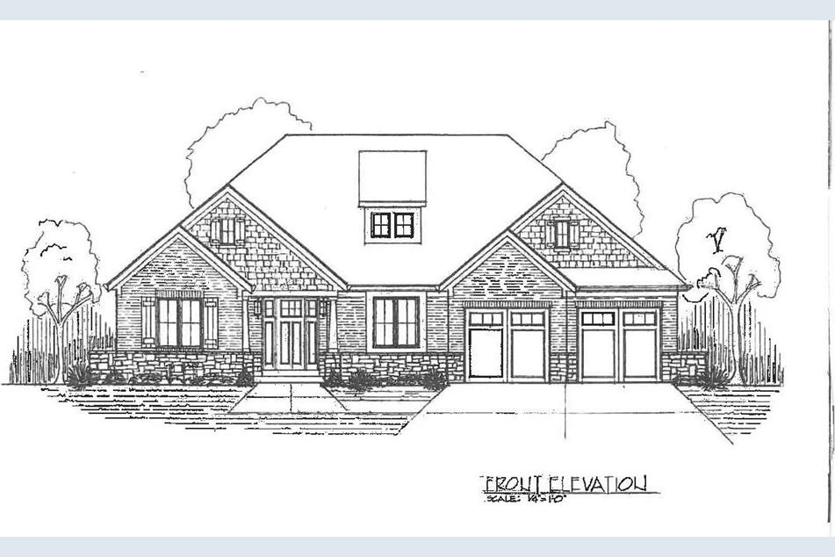

**1/1**

**Full Property Details**

**GENERAL**

* **Price:** $399,900
* **Status:** Active
* **Type:** Single Family
* **MLS ID:** 1645819
* **Updated:** 5/19/2020

**INTERIOR**

* **Number of Rooms:** 7
* **Interior Features:** Multi-Panel Doors
* **Fireplace:** Yes
* **Number of Fireplaces:** 1
* **Fireplace(s):** Gas

**ROOMS**

**bathrooms**

* **Total Bathrooms:** 2
* **Full Bathrooms:** 2
* **Master Bathroom:** Built-In Shower Seat, Tile Floor
* **Bathroom 1:** Full, Level 1
* **Bathroom 2:** Full, Level 1

**bedrooms**

* **Total Bedrooms:** 3
* **Master Bedroom:** WW Carpet, 17 x 14, Level 1, 238 Sq. Ft.
* **Bedroom 2:** 14 x 11, Level 1, 154 Sq. Ft.
* **Bedroom 3:** 13 x 11, Level 1, 143 Sq. Ft.

**other rooms**

* **Foyer/Entry:** Wood Floor, 12 x 7, Level 1
* **Great Room:** Wood Floor
* **Kitchen:** Marble/Granite/Slate, Wood Cabinets, Wood Floor, 18 x 13, Level 1, 234 Sq. Ft.
* **Dining Room:** Chair Rail, Wood Floor, 15 x 12, Level 1, 180 Sq. Ft.
* **Breakfast Room:** 13 x 11, Level 1, 143 Sq. Ft.
* **Office/Den/Study:** 13 x 10, Level 1, 130 Sq. Ft.
* **Laundry:** 8 x 5, Level 1, 40 Sq. Ft.